Name: Rith Chankolboth ID: p20240038

* 1. Clarity: Netflix

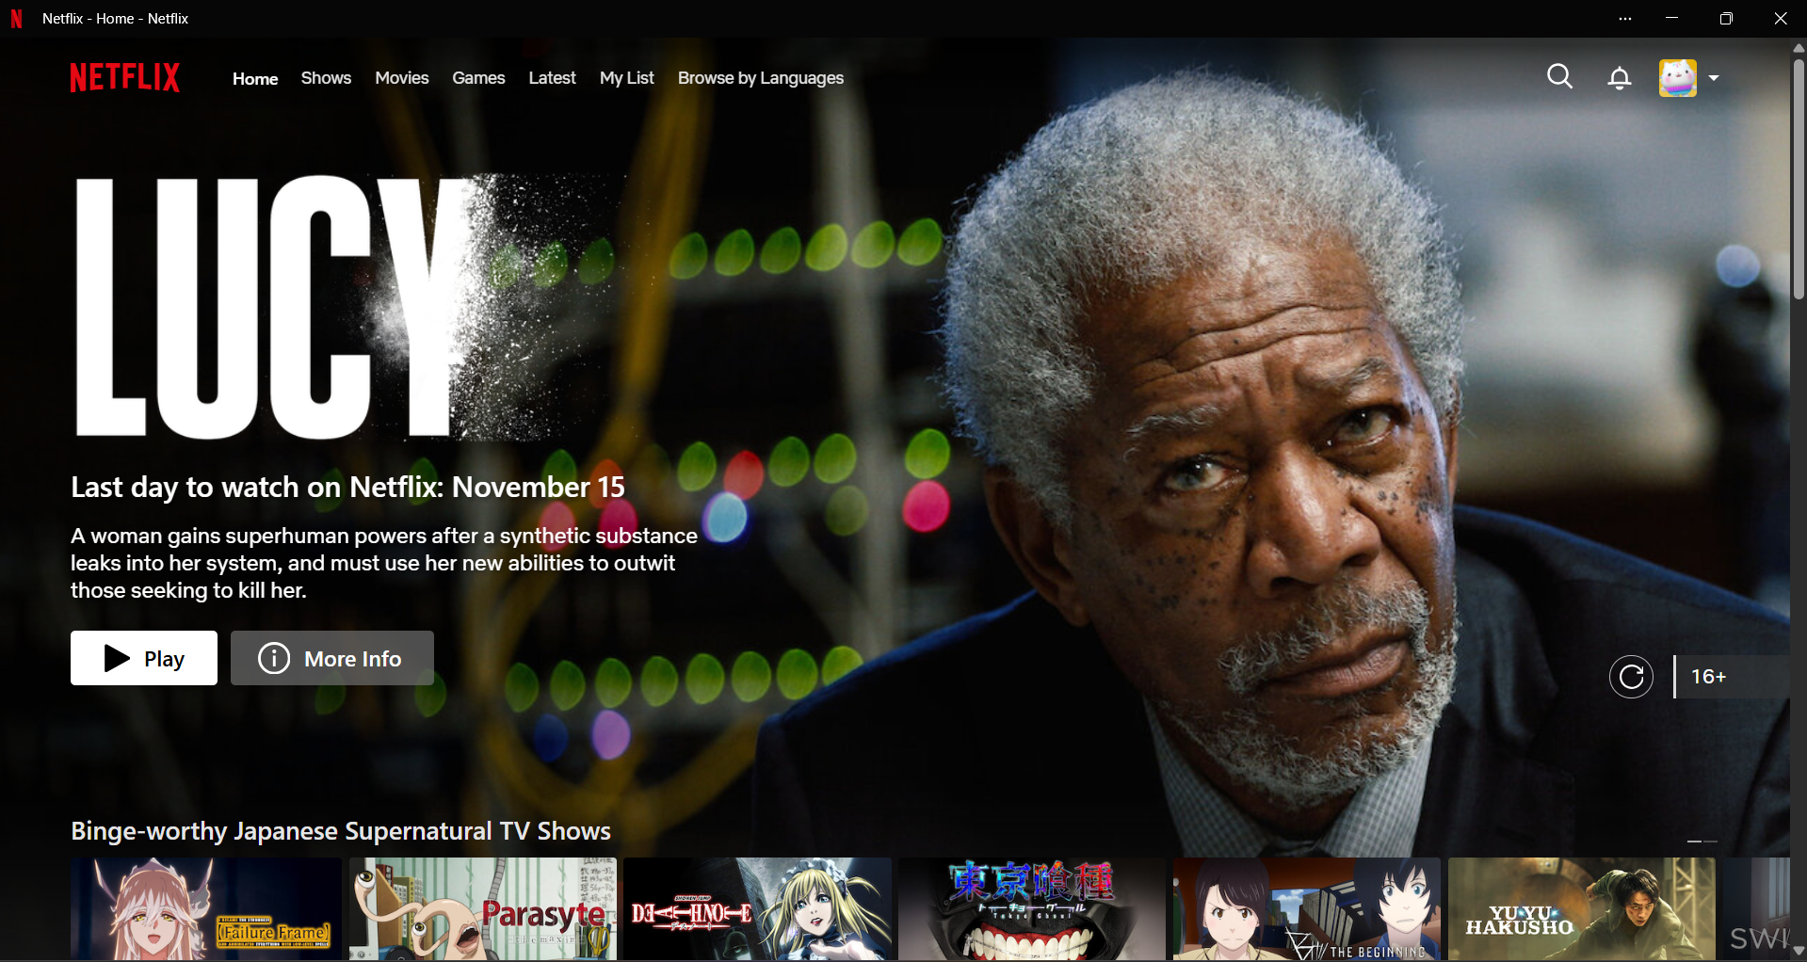

Netflix is a popular subscription-based streaming service that offers a wide variety of movies, TV shows, documentaries, and other content on internet-connected devices.

Clarity: It allows user to access various function at the top of the page such as such as home, shows, categories, account, search…etc. All of the function is a button which is text not icon (except for the most common which is search and notification) to avoid confusion. If you scroll down to explore there is only movies and shows which is click to watch, like, add to list and description. All the important function was at the top which gives clarity.

* 1. Clarity: Calculator

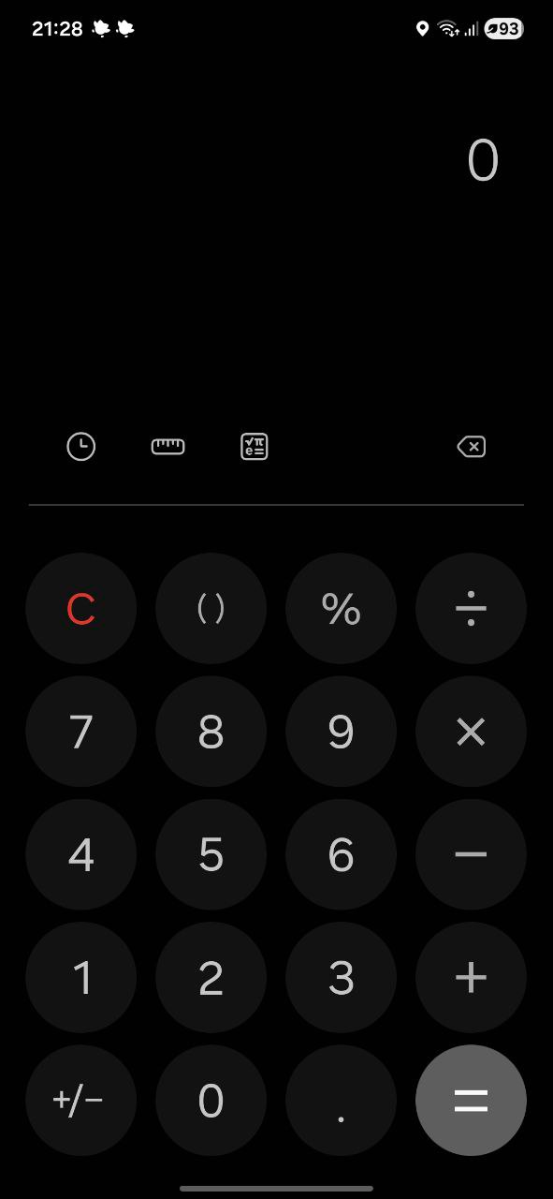

Simplicity: Allow user to calculate very easily, there’s only three other function which is history, unit conversion and more complex calculation. Every button is clear and intuitive.

* 1. Usability: Microsoft word

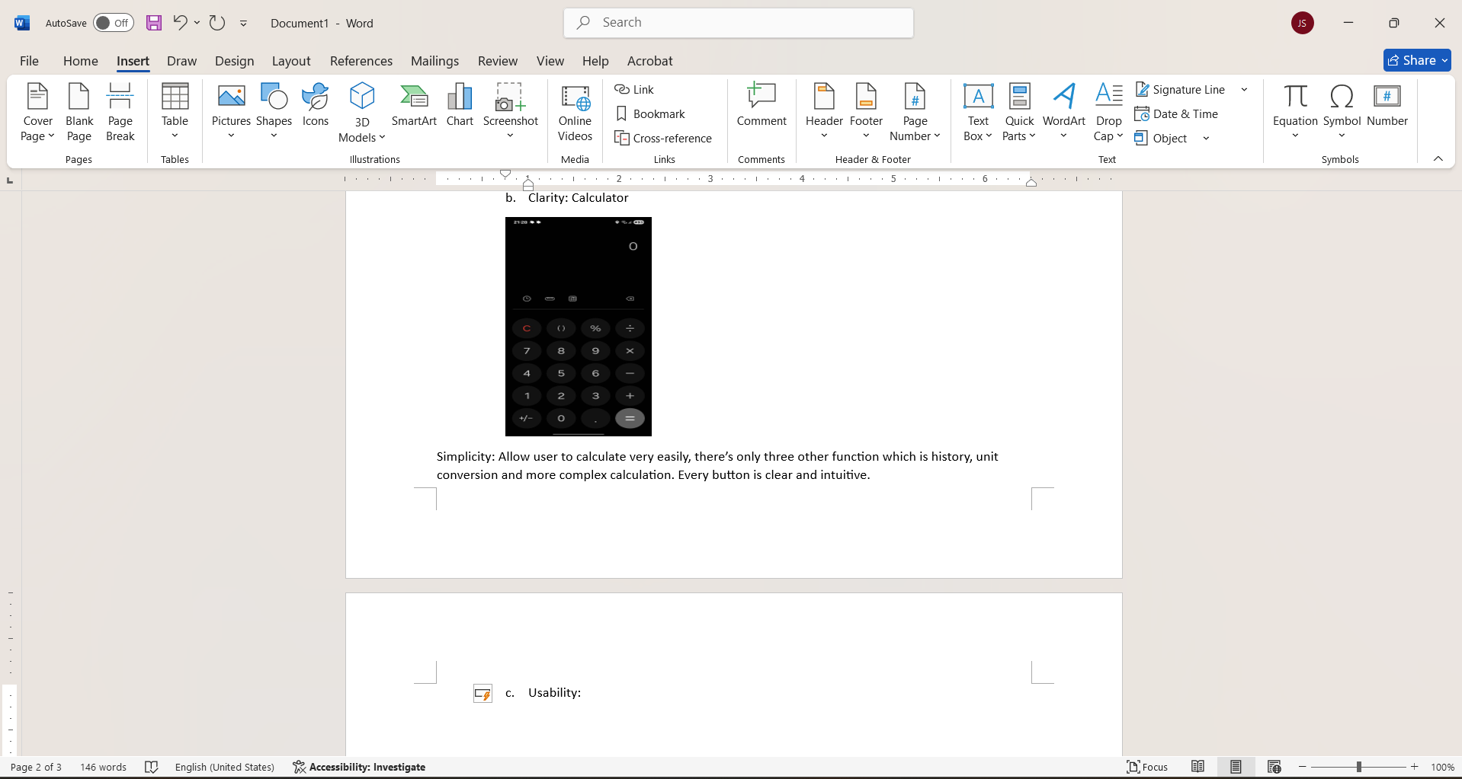

Usability: Microsoft word have a lot of functions needed to write any type of document; all the functions are group in tabs allow for organize workspace and somewhat intuitive browsing for function.

1. Website: Youtube

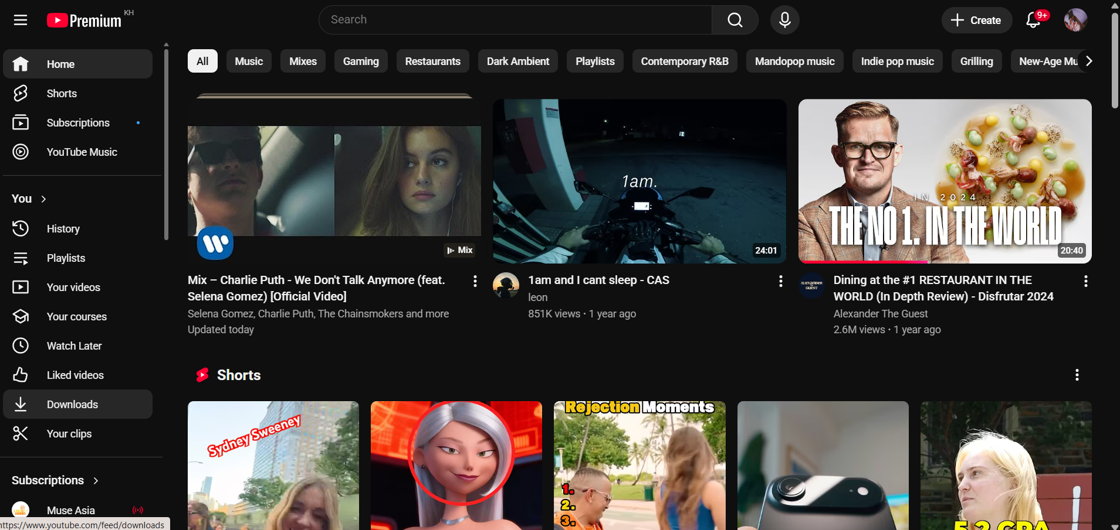

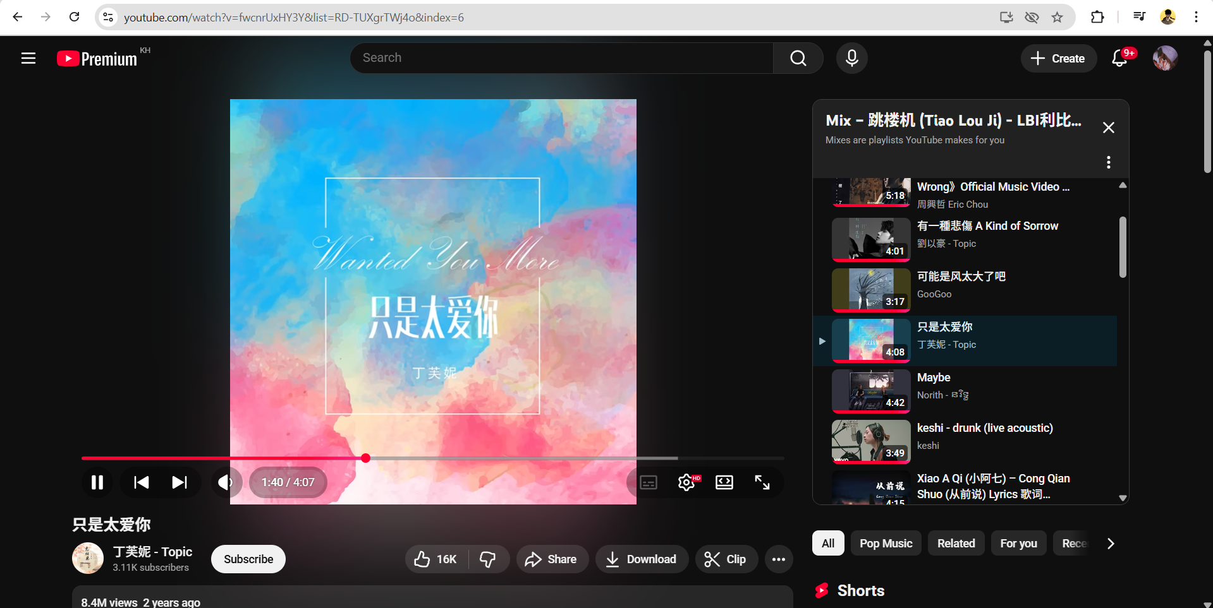

* 1. The website feels easy to use, every common function is practically one click away and other not so common ones are intuitive and easy to find most if not all are less than 5 clicks away.
  2. I like it that home page is always one click away, there’s nothing to critique
  3. It uses search-based information architecture
  4. Sitemap

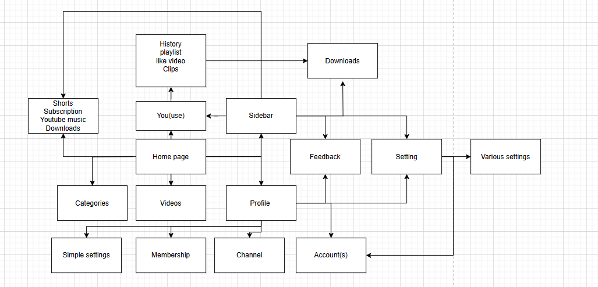

* 1. Youtube use F patterns

1. Food Panda ordering (with coupons)

Home>event page (flash in this case)>pick a restaurant>pick food>open cart>Apply voucher> voucher reach limit>review payment and address>place order.

There should have been a warning before pressing the event or remove it entirely when voucher reach limit.

